Binsense Deployment on AWS
This comprehensive guide details the step-by-step process for deploying the Binsense application on Amazon Web Services (AWS).

Prerequisites
- AWS CLI
  - Install and configure AWS CLI locally
  - Download from: https://aws.amazon.com/cli/
- Docker
  - Install Docker locally
  - Download from: https://docs.docker.com/get-docker/

Overview
The deployment process consists of the following steps: 1. Run project locally 2. Build Docker image locally 3. Push Docker image to AWS ECR 4. Create EC2 Instance 5. Install Docker on EC2 Instance 6. Pull Docker Image to EC2 Instance 7. Run Docker Image on EC2 Instance

Run Project Locally

Install Project Requirements
- Navigate to the Binsense project directory in your terminal
- Execute the following command:
- pip3 install -r requirements.txt
- Alternatively, if using virtualenv/pipenv:
- pipenv install -r requirements.txt
- 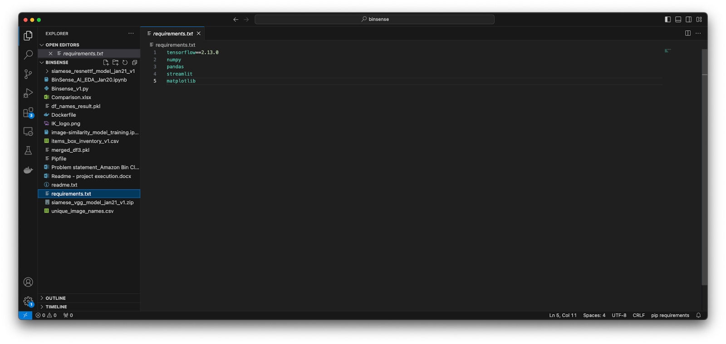
This will install all dependencies listed in the binsense/requirements.txt file.

Run Project
- Start the application by running:
- streamlit run Binsense_v1.py
- 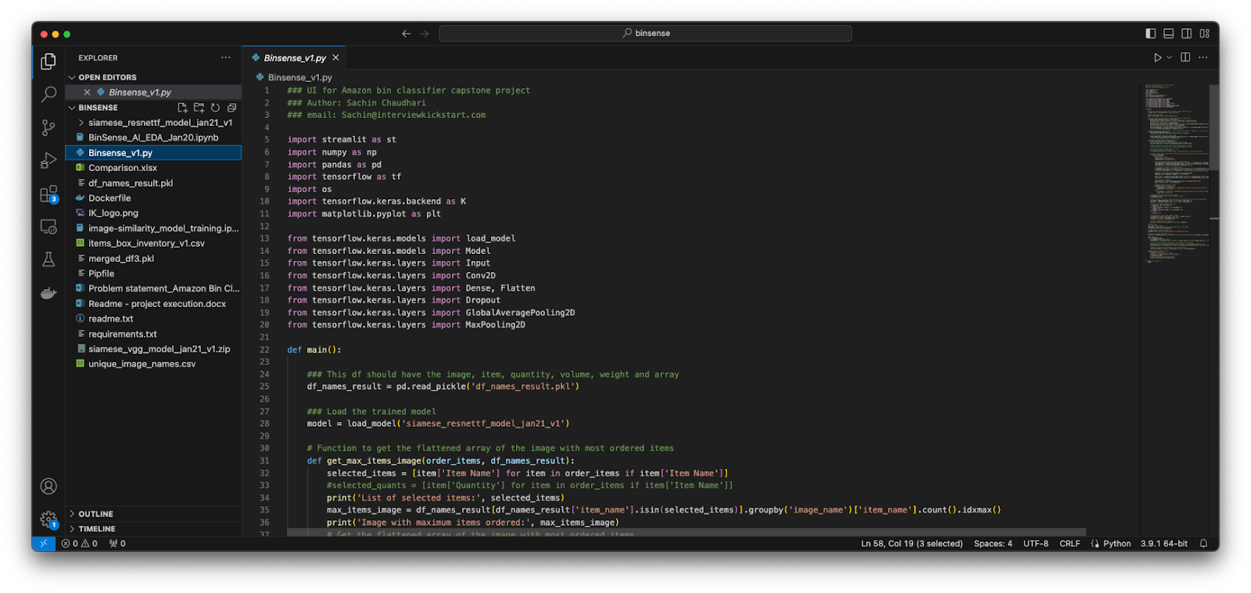
- Access the application at: http://localhost:8501

Build Docker Image Locally
- In the Binsense project directory, execute:
- docker build -t binsense .
- 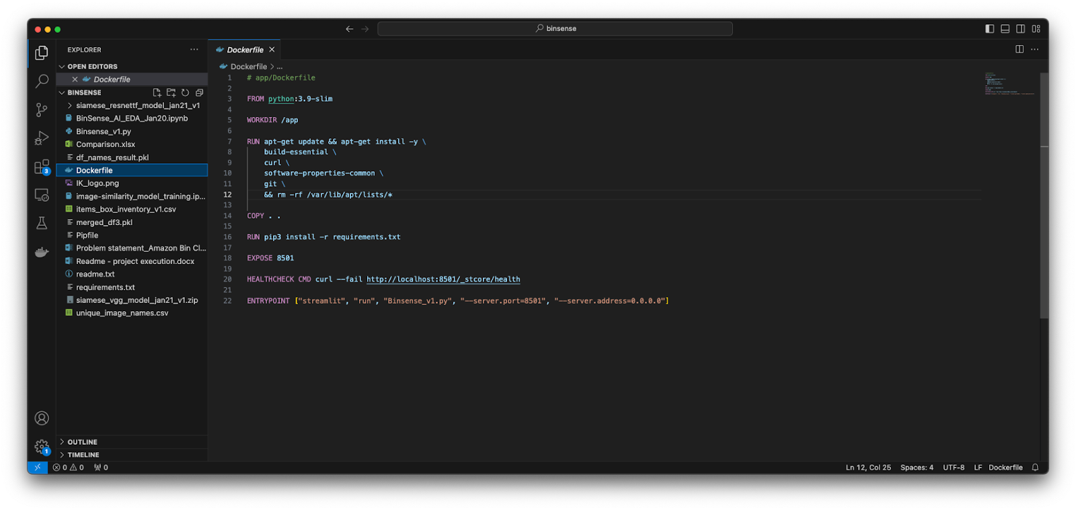
- This command builds a Docker image using the Dockerfile in the project directory.
- Verify the image creation:
- docker images

Run Docker Image Locally (Optional)
To verify the Docker image functionality:
- Run the container:
- docker run -p 8501:8501 binsense
- Access the application at: http://localhost:8501
- 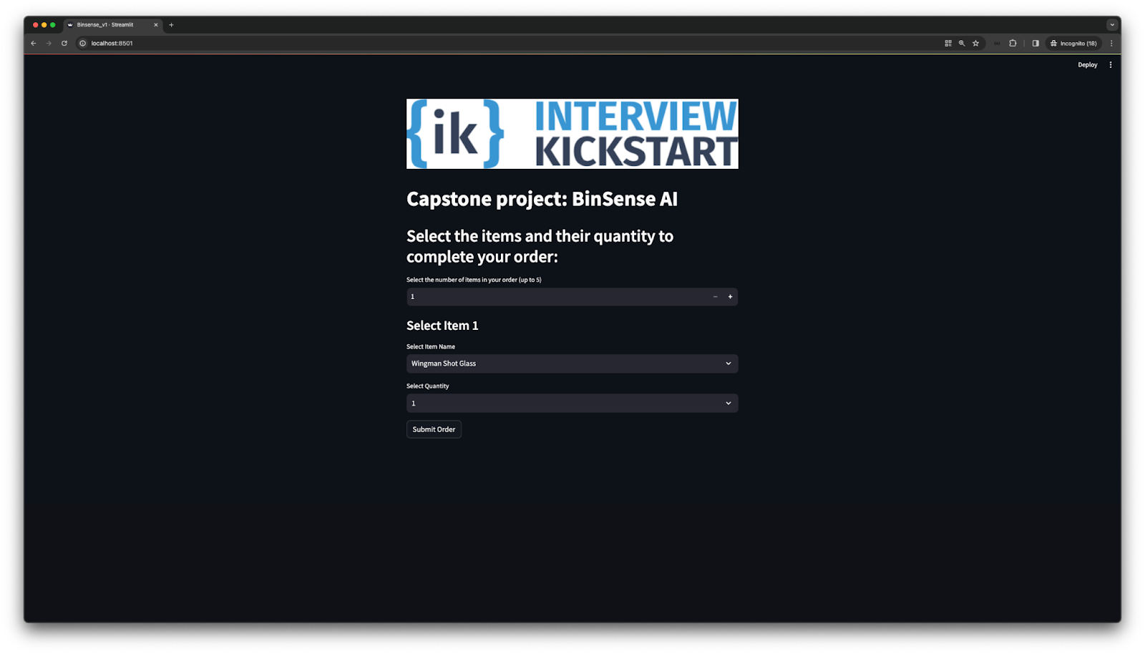

Push Docker Container to AWS ECR (Elastic Container Registry)

Step-by-Step ECR Setup
- Navigate to the Elastic Container Registry page in AWS console
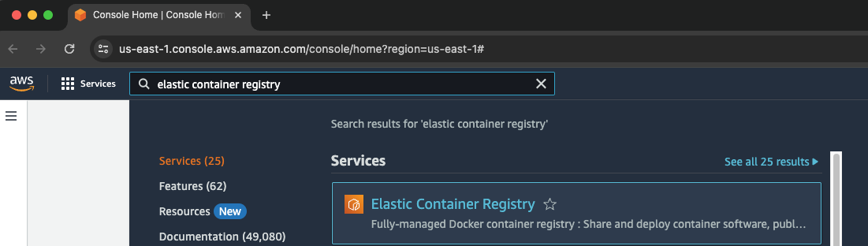
- Create a new ECR repository:
  - Click “Create repository”

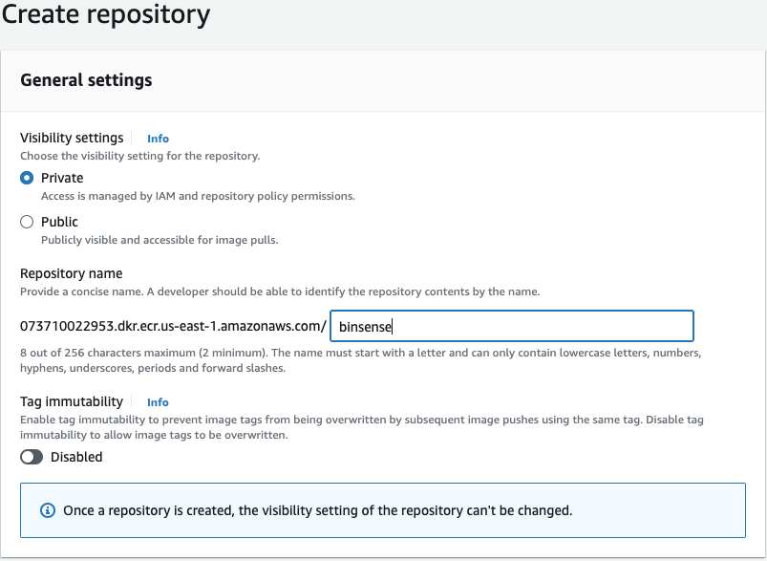
  - Choose “Private” repository
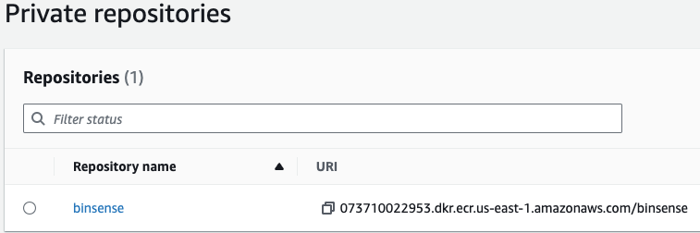
  - Enter repository name
  - Click “Create repository”
- Select the repository from the private repositories page
- Click “View push commands” in the top right corner
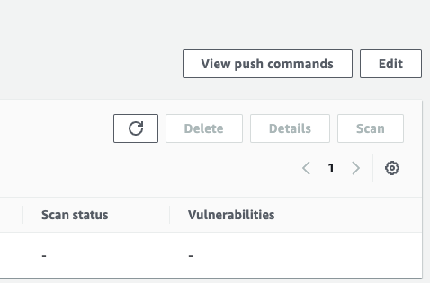
- Follow the provided push commands in order:
  - Authenticate your Docker client to your registry
  - Build your Docker image
  - Tag your image
  - Push the image to AWS ECR
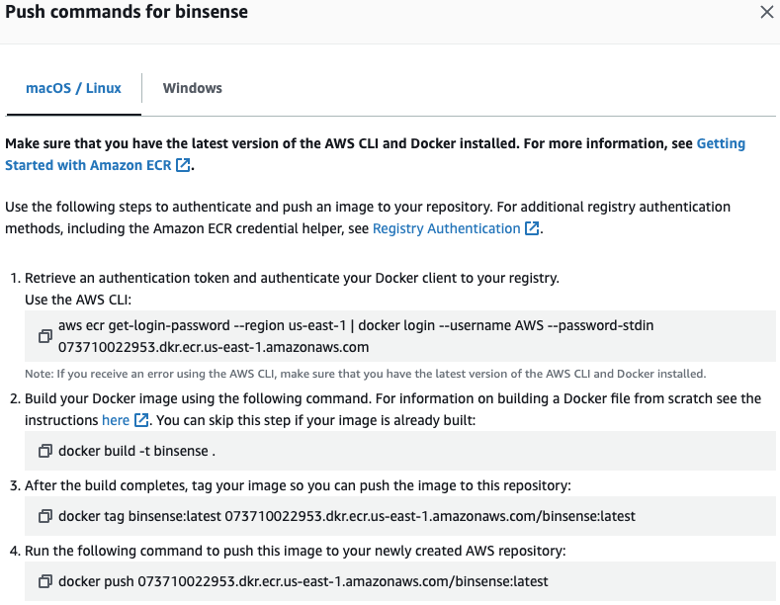
- Verify that the image appears in your ECR repository
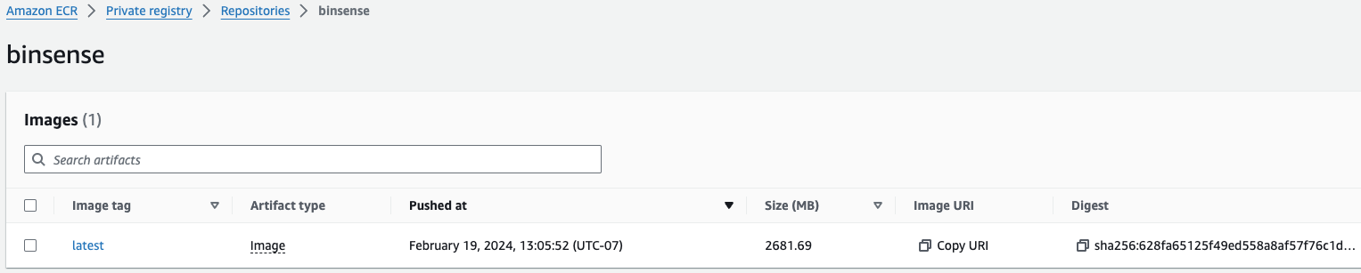

Create EC2 Instance
- Navigate to the AWS EC2 Page in AWS Console

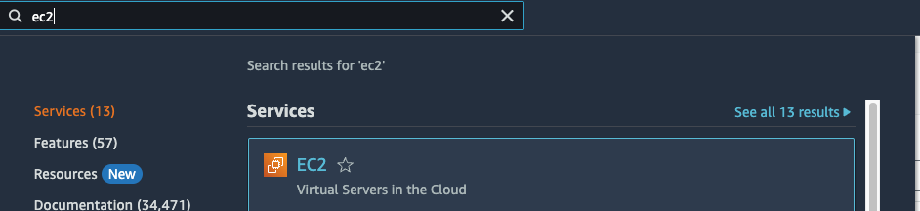
- Click “Launch instance”
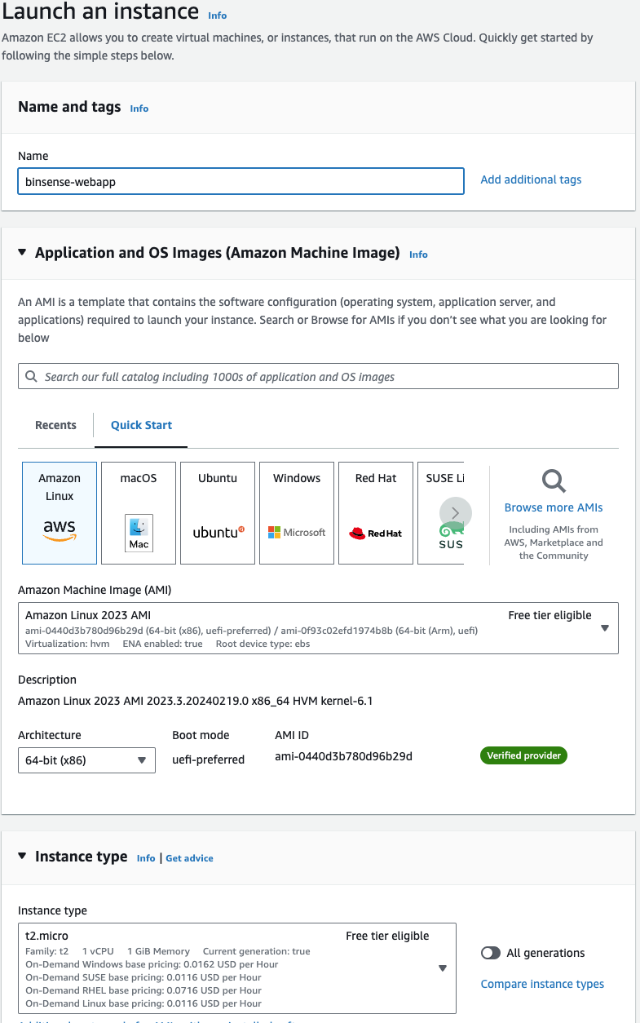
- Configure the instance:
  - Name your instance
  - Select Amazon Linux 2 AMI
  - Choose instance type:
    - t2.micro for verification purposes
    - t2.xlarge for production use cases
  - Create a new key pair (keep track of the .pem file location)
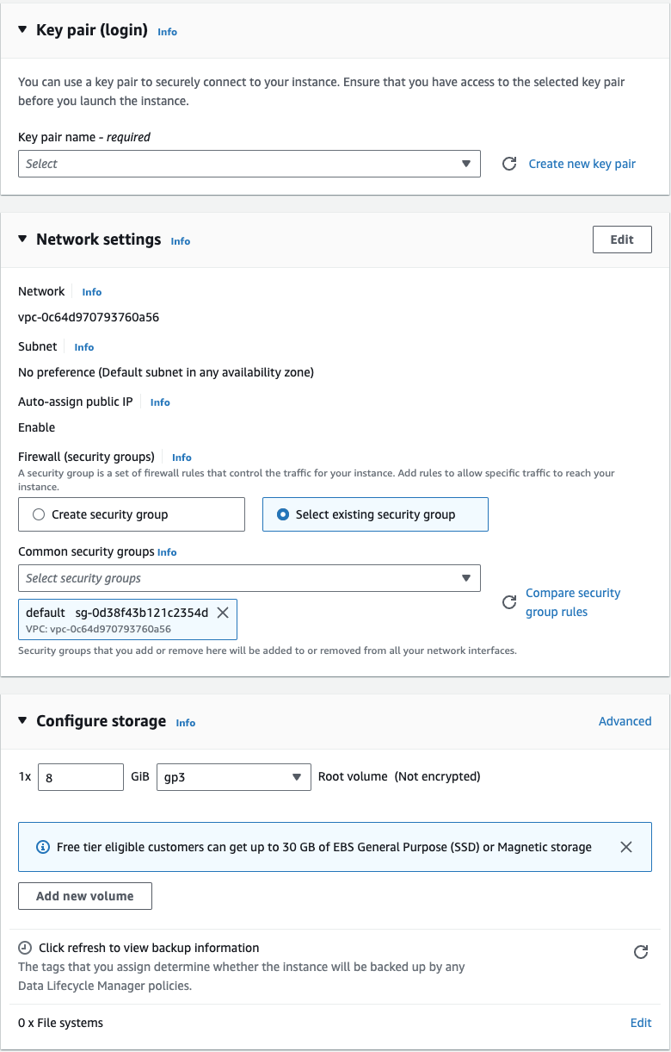
  - Select or create a security group
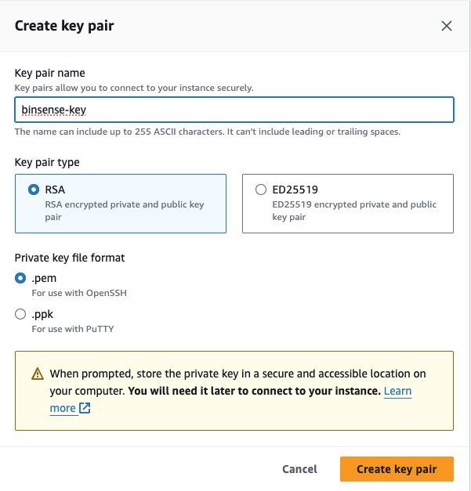
  - Configure other settings as needed
  - Click “Launch instance”
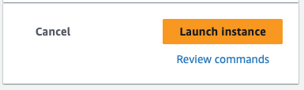
- SSH into the EC2 instance:
- ssh -i /path/to/your-key.pem ec2-user@your-instance-public-dns
- 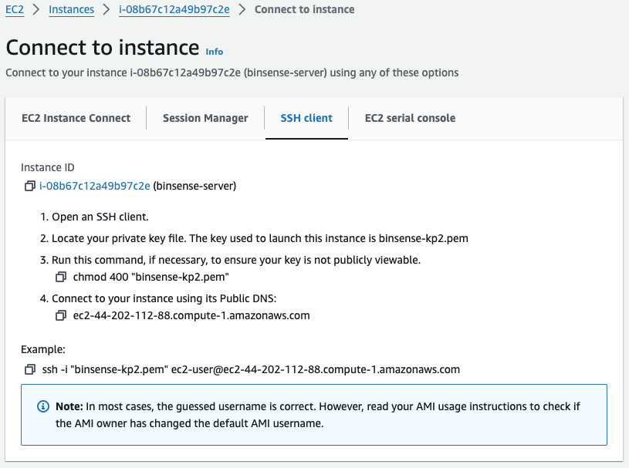
- 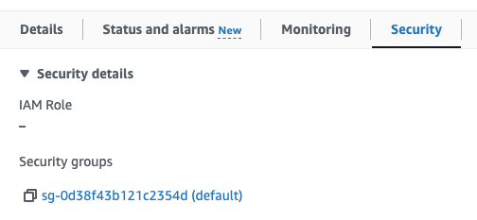
- 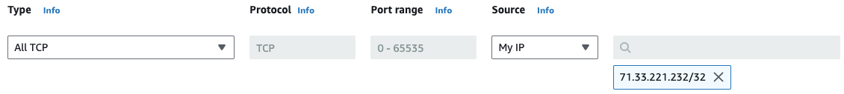

Note: Ensure your security group allows SSH access from your IP address by editing inbound rules.

Install Docker on EC2 Instance
- Connect to your EC2 instance via SSH
- Install Docker:
- sudo yum install docker
- Reboot EC2 Instance:
  - Return to AWS Console
  - Select your instance
  - Click “Instance state”
  - Select “Reboot instance”
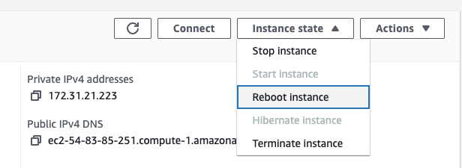

Pull Docker Image to EC2 Instance
- Configure AWS on the EC2 Instance:
  - Create an access key from your IAM user page
  - Note both “Access key ID” and “Secret access key”
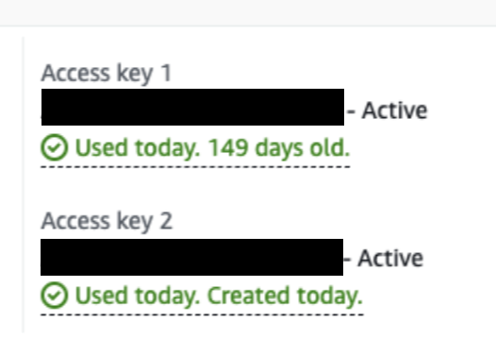
- SSH back into the EC2 instance after reboot
- Configure AWS CLI:
- aws configure
- [ec2-user@ip-172-31-21-223 ~]$ aws configure
- AWS Access Key ID [None]: <access key id>
- AWS Secret Access Key [None]: <secret access>
- Default region name [us-east-1]:
- Default output format [None]:
- Enter the following when prompted:
  - AWS Access Key ID
  - AWS Secret Access Key
  - Default region name (e.g., us-east-1)
  - Default output format (leave empty)
- Start the Docker service:
- sudo service docker start
- [ec2-user@ip-172-31-86-253 ~]$ sudo service docker start
- Navigate to AWS Console ECR page
- Click “View push commands”
- Execute the authentication command in your EC2 instance:
- aws ecr get-login-password --region <region> | docker login --username AWS --password-stdin <aws-account-id>.dkr.ecr.<region>.amazonaws.com
- 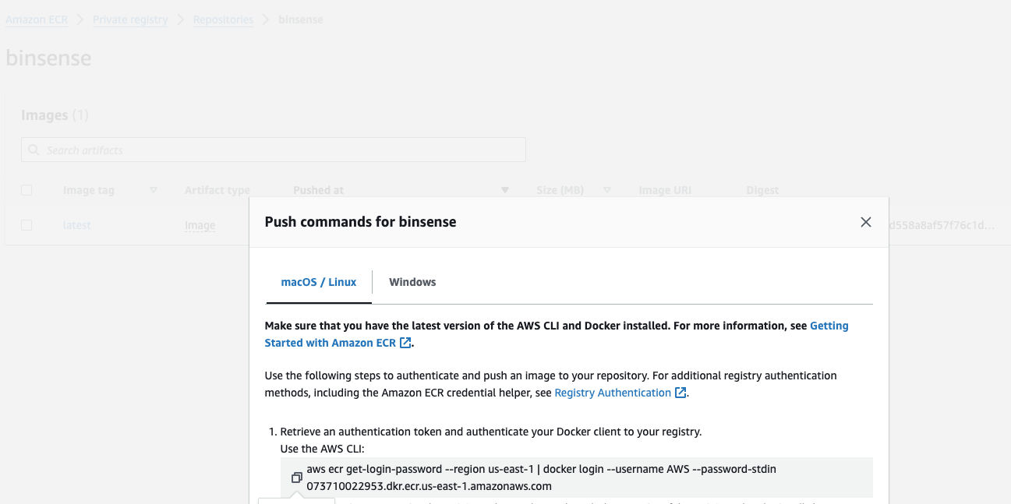
- Pull the Docker image:
- docker pull <image URI>
- 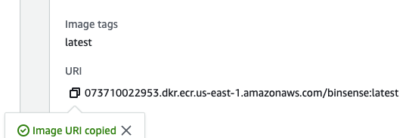
- Run the Docker image:
- docker run -p 8501:8501 <image URI>
- [ec2-user@ip-172-31-21-223 ~]$ docker run <image URI>
- Configure Security Group:
  - Navigate to your EC2 instance’s security group
  - Add inbound rule allowing port 8501 for all traffic

- Access the Application:
  - Find your EC2 instance’s public DNS in the AWS console
  - Access the application at: http://:8501
- 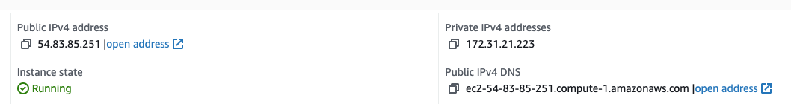
Important Note: The application will only run on HTTP, not HTTPS, as it is not configured for secure communication.

Security Group Configuration Reference
Ensure your security group has the following inbound rules: - SSH (Port 22) from your IP address - Custom TCP (Port 8501) from anywhere (0.0.0.0/0)

Troubleshooting Tips
- If unable to connect via SSH:
  - Verify security group inbound rules
  - Check key pair permissions (chmod 400)
  - Confirm instance is running
- If Docker commands fail:
  - Verify Docker service is running
  - Check Docker permissions
  - Confirm AWS ECR authentication
- If application is inaccessible:
  - Verify security group allows port 8501
  - Check Docker container logs
  - Confirm instance public DNS is correct

